***2-title.png***

***3-intro.png***

***5-dslibraries.png***

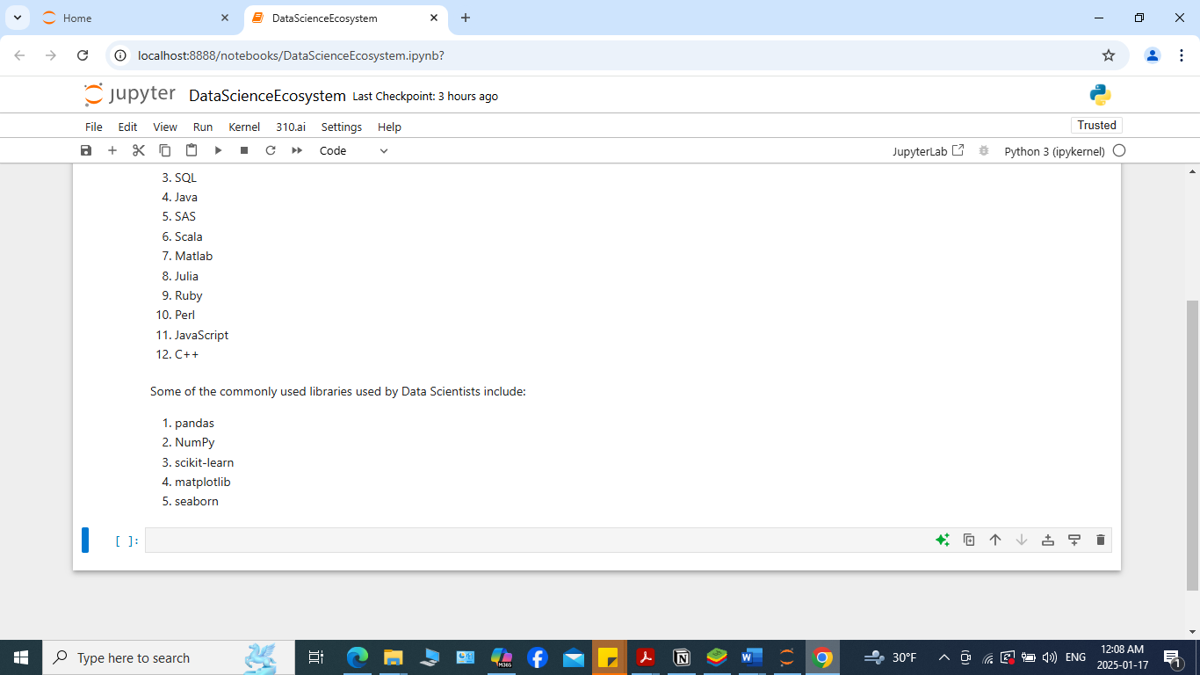

***6-dstools.png***

***7-introarithmetic.png***

***8-multiplyandaddintegers.png***

***9-hourstominutes.png***

***10-objectives.png***

***11-authordetails.png***

